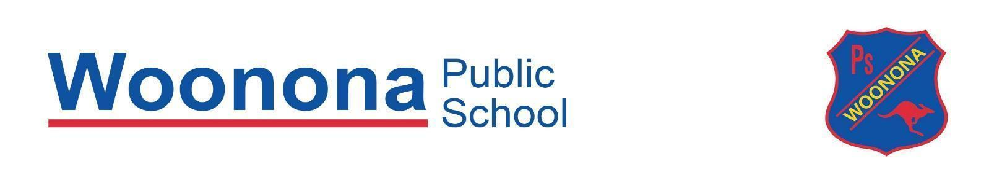
Cross Country Carnival for Years 2 to 6

Wednesday 2 April 2025

This year’s School Cross Country Carnival will be held at Hollymount Park on Wednesday 2 April (Backup Date Wednesday 9 April 2025). All students from Years 2-6 will participate in the cross country event.

Please note that the K-1 Cross Country will be held on our school grounds in Term 2. More information will be made available closer to the date.

Information:
- All students who turn 8 or above in 2025 will compete in the cross country event with the chance to qualify for the district carnival:
  - Junior course (8, 9 and 10 years) approximately 2km
  - Senior course (11 and 12/13 years) approximately 3km

- Students in Year 2 who are turning 7 in 2025 will run in their own race and are not eligible to qualify for the district carnival.

- All staff in Year 2 to Year 6 will be in attendance on the day, therefore we expect all students to attend. Those students who are not competitive runners may compete at their own pace and enjoy the success of competing and contributing to their house points.

- All students will participate in a range of games and activities with their teacher while not running.

- As the cross country is not a timed event, students must be in attendance on the day to qualify for the district carnival. If there are exceptional circumstances, please contact Mr Argaet through the school office.

- Students will walk to Hollymount Park with a classroom teacher, departing school at 9:15am and returning at approximately 1:00pm.

- Order of events:
11:00am – 10 years boys
11:15am – 10 years girls
11:30am – 11 years boys
11:50am – 11 years girls
12:10pm – 12/13 years boys
12:30pm – 12/13 years girls

9:45am – All students walk the course
10:10am – 7 years boys
10:20am – 7 years girls
10:30am – 8/9 years boys
10:45am – 8/9 years girls

- If you wish to take your child home early, they must be signed out at the recording table at Hollymount Park.

- Students are to wear sports uniform, including hat, or house colours. Students are to bring their bag with lunch, a water bottle and sunscreen.

- If your child has any medical conditions that supervising teachers need to be aware of, please complete the attached form. Children who suffer from asthma should carry a puffer. This form needs to be returned to the school office by Wednesday 26 March.

- As this event is covered by the ‘Permission to Walk’ note, no permission slip needs to be returned. If you do not wish for your child to participate in this event, please contact the school office.

Backup Carnival
In the event of a postponement of the 2-6 Cross Country Carnival, the backup carnival will be held at Hollymount Park on Wednesday 9 April 2025. In the event of wet weather, parents will be notified of cancellation via our school communication channels.

We look forward to a fantastic day of fun, fitness and fresh air!

Mr Argaet

Carnival Organiser

✂………………………………………………………………….…………………………………………….
(Only to be returned in the event your child has a medical condition by Wednesday 26 March)

Cross Country Medical Note

Wednesday 2 April 2025

Students Name: ________________________________________ Date: __________________

Medical conditions that may affect my child: (Children who suffer from asthma should carry a puffer)_________________________________________________________________________ ________________________________________________________________________________________________________________________________________________________________________________________________________________________________________________________________________________________________________________________

Parent/Carer Signature: _________________________________ Date: ___________________

